Merykokeb Belay

Mary Kryslette Bunyi

Maryam Khalid Shah

**Case Description:**

**Using Facial Recognition Technology (FRT) for Law Enforcement**

*Facial recognition helps South Wales Police become smarter, creating a safer and connected community.*

— South Wales Police official website[1]

*We recognise the police are doing a difficult job with dwindling resources, but there is a balance to be struck between their need to fight crime and the public's need to feel reassured, and that their rights are being respected.*

— Ed Bridges, August 11, 2020[2]

**Ed Bridges vs. South Wales Police**

In December 2017, Ed Bridges was Christmas shopping in Cardiff city center when his image was captured by AFR Locate – an automatic facial recognition (AFR) software being used by the South Wales Police (SWP) that would automatically scan the faces of people and compare them to images on a database of persons of interest (Shead 2020). Mr. Bridges, a father of two and a civil liberties campaigner, was not a person of interest and had never been on a watch list (Rees 2020).

A few months later when Mr. Bridges was participating in a peaceful anti-arms protest outside Cardiff’s Motorpoint Arena in 2018, his face was scanned again by AFR Locate (Rees 2020). Upset that his human rights were breached by his biometric data being analysed without his knowledge or consent and concerned that AFR Locate was an attempt “to deter us from using our rights to peaceful protest”[3], Mr. Bridges decided to reach out to Liberty, a civil rights organization[4]. With the help of Liberty, he took the case to court arguing that the use of the tool breached his data protection and equity laws, as well as his rights to privacy. Mr. Bridges felt there was no other choice. Proper public consultations were not made; bringing the case to court was their only chance to challenge the use of the technology[5].

The judicial review in the High Court of London held in May 2019 was the first time any court in the world has considered the use of the technology[6]. The court’s key findings included that SWP’s use of AFR met the requirements of the Human Rights Act, that it was processing personal data in a lawful manner, and that it had complied with equality laws[7].

*This sinister technology undermines our privacy and I will continue to fight against its unlawful use to ensure our rights are protected and we are free from disproportionate government surveillance.*

— Ed Bridges, August 11, 2020[8]

The subsequent appeal by Liberty and Mr. Bridges was upheld by the Court of Appeals on the following three of the five points raised in the appeal[9]:

* There was no clear guidance on where AFR Locate could be used and who could be put on a watchlist.
* A data protection impact assessment was deficient.
* The force did not take reasonable steps to find out if the software had a racial or gender bias.

The judges stated that the benefits of technology are potentially great and the intrusions into people’s privacy are minor, but expressed a need for more care in terms of clear documentation of who police officers are looking for and what evidence they have that those targets are likely to be monitored in the area[10].

Responding to the ruling, SWP said that it was committed to carefully developing and using the technology which had resulted in 61 people being arrested for offences including violence and robbery, while causing no unlawful arrest[11].

**Acquiring AFR Locate**

In January 2017, the Home Office Police Transformation Fund awarded SWP with £1,950,000[12]. The police department had submitted a funding request to acquire and pilot AFR technologies, citing several expected benefits to policing. In addition to the funds received from the Home Office, SWP committed £600,000 to the project[13]. The procurement and implementation process would involve a public call for tenders and a 10-month trial period where the winning software would be deployed at a series of local events that were certain to draw large crowds. The Champions League, an upcoming football game expected to have more than 170,000 local and foreign attendees, would be the first event where AFR would be piloted. It presented the perfect opportunity for the police department to test the effectiveness of AFR in real-time.

Soon after receiving the award, the police department placed a call for suppliers to submit an application. Applicants were judged on two factors: “product quality and value for money”[14]. After a competitive bidding process, the contract was awarded to a Japanese informational technology company called Nippon Electric Company (NEC). NEC would provide the police department with an AFR system that was based on the NeoFace Facial Recognition application. This proprietary, black-box facial recognition technology has been widely adopted by government agencies and private companies globally, particularly by police departments, banks, and airports. In addition to preparing the software, NEC would also provide in-person training and advise the police force on additional hardware and equipment that would need to be purchased to operate the software[15].

**Why AFR?**

Like many who decide to incorporate automated decision systems in their daily work, the SWP wanted to leverage AFR technologies to improve existing policing tasks. Among the many justifications provided in the funding application to the Home Office, the police force cited potential benefits in terms of public safety, cost-savings, procedural efficiency, and finally, community cohesion. With regards to public safety and procedural efficiency, SWP was eager to use AFR technologies at large events that make policing especially difficult. Given the limited number of police officers and resources the force has, incorporating the real-time image matching capabilities of AFR would make the detection of imminent threats to public safety more effective and efficient[16]. From a cost-savings standpoint, SWP anticipated AFR Locate to alleviate the police department’s financial hardships by decreasing the amount of time and resources spent on protracted investigations. The police force also expected “reductions in repeat offending and anticipated increased community cohesion”[17].

**Implementing AFR**

Preparation for the deployment of AFR Locate at the Champions League occured in several stages. Following the guidance of NEC staff, the police department purchased “12 Alienware laptops; 4 mobile camera vans as shown in Exhibit 1 (each fitted with two ‘pan, tilt, zoom’ cameras); and 14 additional cameras”[18]. Recognizing the scale of policing challenges that would be present at the League, the SWP hired operators that would solely work on this project. These operators would receive training on both technical and operational procedures. NEC engineers were in-charge of directing the technical aspects of the training: they held a 3-hour session where operators were briefed on facial recognition technology and given hands-on demonstrations on how to operate the AFR Locate software in real-time. This involved a detailed explanation of the ‘scoring-function’—a manually-adjustable threshold that represents the probability that a real-time camera image taken by AFR is the same as a picture from a database of preselected facial images[19]. The AFR system would return a match if it meets or exceeds the threshold. Operators also received training on operational procedures—this part of the training was provided by senior officers at the department and involved an overview of the logistical aspects of the Champions League deployment[20]. These would be the last formal training sessions provided by the SWP and NEC. Operators hired after the Champions League deployment would rely on guidance from former operators when using AFR[21].

**How AFR Locate Worked**

AFR Locate involved real-time monitoring of a location with the algorithm checking faces passing through the field of vision of a camera against a defined watchlist of images which could include suspects, missing people or persons of interest. Watchlists typically contained between 600-800 individuals (the total number was 1200 at the Champions League due to the scale of the event)[22]. As shown in Exhibit 2, when a possible match with an image was made, this was reviewed by the operator, and if they confirmed the possible match then a policing intervention was undertaken[23]. The precise functioning of this algorithm was ‘black boxed’ i.e. NEC had not revealed precisely how matches were being calculated by the system to the SWP[24].

An evaluation of SWP’s use of AFR found that the technology lagged when there were large crowds, and struggled in low light[25]. Following the Champions League pilot study in which a high number of false positives was generated and the system lagged frequently, NEC offered to install a new algorithm (M20) across the SWP platforms which significantly improved the performance of AFR Locate[26].

**Aftermath of the Court Judgment**

*Our priority remains protecting the public, and that goes hand-in-hand with a commitment to ensuring they can see we are using new technology in ways that are responsible and fair.*

— Matt Jukes, Chief Constable, South Wales Police, August 11, 2020[27]

Following the Court of Appeal’s ruling that AFR Locate encroached on privacy rights and failed to substantially control for bias[28], demands have increased for the police force to cease the use of AFR altogether. Nonetheless, SWP welcomed the court’s probe into AFR Locate as a step towards the technology’s development and reiterated its commitment to “careful development and deployment”[29]. Deputy Chief Constable Jeremy Vaughan stated that, “This judgment will only strengthen the work which is already underway to ensure that the operational policies we have in place can withstand robust legal challenge and public scrutiny.”[30]

SWP is in discussions with other government agencies such as the Surveillance Camera Commissioner, Home Office, College of Policing, and National Police Chiefs Council to incorporate court findings into operational guidance[31]. A systems audit by the University of Police Science Institute in Cardiff was likewise commissioned in November 2019 to investigate AFR Locate algorithms for gender and race bias[32]. To allay public concerns, the SWP assured that community engagement and public information are top priorities; all AFR Locate deployments are conspicuous and actively publicized[33]. The SWP was also unequivocal that facial images that do not result in matches are immediately deleted and are inaccessible to the police[34] -- information that Ed Bridges felt was not properly communicated to the public[35]. The court ruling, which found that SWP possessed excessive discretion in the use of AFR Locate, has been noted to put pressure on the government to craft a regulatory framework controlling the use of AFR in policing[36].

AFR Locate generated one true positive alert in January 2020 during the concert of heavy metal band Slipknot inside Cardiff’s Motorpoint Arena -- the same location where Ed Bridges’ face was scanned for the second time[37]. No other deployments have been carried out since[38]. However, the Slipknot concert will likely not be the last. Convinced in the good that the technology brings, the SWP has expressed confidence that the deployment of AFR Locate will resume once they sufficiently address court findings[39].

**Bibliography**

BBC. “Facial recognition: What led Ed Bridges to take on South Wales Police?” August 11, 2020. <https://www.bbc.com/news/uk-wales-53742099>.

Bethan, Martin, and Andrew Dawson. *An Evaluation Of South Wales Police’s Use Of Automated Facial Recognition*. Cardiff University, 2018.<https://crimeandsecurity.org/s/AFR-Report-Digital.pdf>.

Rees, Jenny. “South Wales Police use of facial recognition ruled lawful”. *BBC News*, September 2019.<https://www.bbc.com/news/uk-wales-49565287>.

Rees, Jenny. “Facial recognition use by South Wales Police ruled unlawful”. *BBC News*, August 2020.<https://www.bbc.com/news/uk-wales-53734716>.

Sabbagh, Dan. “South Wales police lose landmark facial recognition case”. *The Guardian*, August 11, 2020. <https://www.theguardian.com/technology/2020/aug/11/south-wales-police-lose-landmark-facial-recognition-case>.

South Wales Police. “Court of Appeal Judgement”. August 11, 2020. <https://afr.south-wales.police.uk/blog/court-of-appeal-judgment/>.

South Wales Police. “What is AFR?” <https://afr.south-wales.police.uk/>.

**Exhibit**

Exhibit 1

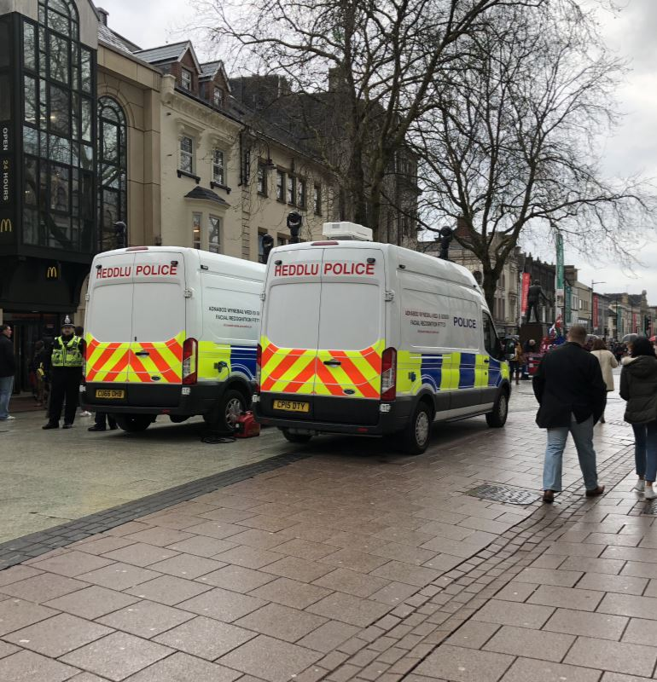

Exhibit 2

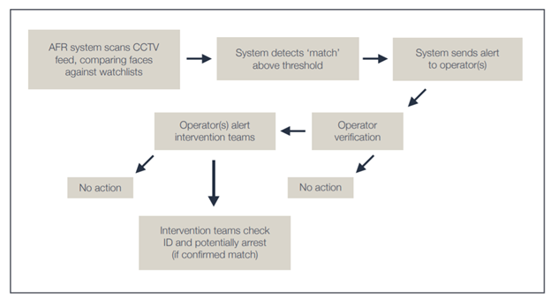

1. South Wales Police. “What is AFR?”
2. BBC. “Facial recognition: What led Ed Bridges to take on South Wales Police?” August 2020.
3. BBC. “Facial recognition: What led Ed Bridges to take on South Wales Police?” August 2020.
4. Rees, Jenny. “Facial recognition use by South Wales Police ruled unlawful”. *BBC News*, August 2020.
5. BBC. “Facial recognition: What led Ed Bridges to take on South Wales Police?” August 2020.
6. Rees, Jenny. “South Wales Police use of facial recognition ruled lawful”. *BBC News*, September 2019.
7. Rees, Jenny. “South Wales Police use of facial recognition ruled lawful”. *BBC News*, September 2019.
8. Rees, Jenny. “South Wales Police use of facial recognition ruled lawful”. *BBC News*, September 2019.
9. Rees, Jenny. “Facial recognition use by South Wales Police ruled unlawful”. *BBC News*, August 2020.
10. Rees, Jenny. “Facial recognition use by South Wales Police ruled unlawful”. *BBC News*, August 2020.
11. Rees, Jenny. “Facial recognition use by South Wales Police ruled unlawful”. *BBC News*, August 2020.
12. Bethan, Martin, and Andrew Dawson. *An Evaluation Of South Wales Police’s Use Of Automated Facial Recognition*.
13. Bethan, Martin, and Andrew Dawson. *An Evaluation Of South Wales Police’s Use Of Automated Facial Recognition*.
14. Bethan, Martin, and Andrew Dawson. *An Evaluation Of South Wales Police’s Use Of Automated Facial Recognition*.
15. Bethan, Martin, and Andrew Dawson. *An Evaluation Of South Wales Police’s Use Of Automated Facial Recognition*.
16. Bethan, Martin, and Andrew Dawson. *An Evaluation Of South Wales Police’s Use Of Automated Facial Recognition*.
17. Bethan, Martin, and Andrew Dawson. *An Evaluation Of South Wales Police’s Use Of Automated Facial Recognition*.
18. Bethan, Martin, and Andrew Dawson. *An Evaluation Of South Wales Police’s Use Of Automated Facial Recognition*.
19. Bethan, Martin, and Andrew Dawson. *An Evaluation Of South Wales Police’s Use Of Automated Facial Recognition*.
20. Bethan, Martin, and Andrew Dawson. *An Evaluation Of South Wales Police’s Use Of Automated Facial Recognition*.
21. Bethan, Martin, and Andrew Dawson. *An Evaluation Of South Wales Police’s Use Of Automated Facial Recognition*.
22. Bethan, Martin, and Andrew Dawson. *An Evaluation Of South Wales Police’s Use Of Automated Facial Recognition*.
23. Bethan, Martin, and Andrew Dawson. *An Evaluation Of South Wales Police’s Use Of Automated Facial Recognition*.
24. Bethan, Martin, and Andrew Dawson. *An Evaluation Of South Wales Police’s Use Of Automated Facial Recognition*.
25. Bethan, Martin, and Andrew Dawson. *An Evaluation Of South Wales Police’s Use Of Automated Facial Recognition*.
26. Bethan, Martin, and Andrew Dawson. *An Evaluation Of South Wales Police’s Use Of Automated Facial Recognition*.
27. South Wales Police. “Court of Appeal Judgement”. August 11, 2020.
28. Sabbagh, Dan. “South Wales police lose landmark facial recognition case”. *The Guardian*, August 2020.
29. South Wales Police. “Court of Appeal Judgement”. August 11, 2020.
30. South Wales Police. “Court of Appeal Judgement”. August 11, 2020.
31. South Wales Police. “Court of Appeal Judgement”. August 11, 2020.
32. South Wales Police. “Court of Appeal Judgement”. August 11, 2020.
33. South Wales Police. “Court of Appeal Judgement”. August 11, 2020.
34. South Wales Police. “Court of Appeal Judgement”. August 11, 2020.
35. BBC. “Facial recognition: What led Ed Bridges to take on South Wales Police?” August 2020.
36. Lomas, Natasha. “Court finds some fault with UK police force’s use of facial recognition tech”. *TechCrunch*, August 2020
37. South Wales Police. “What is AFR?”
38. South Wales Police. “What is AFR?”
39. South Wales Police. “Court of Appeal Judgement”. August 11, 2020.